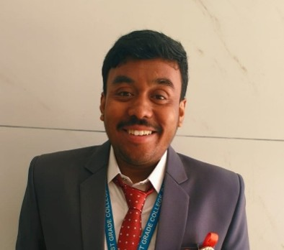
SUBRAMANI A S
Designation: Assistant Professor
Official Email ID: subramanias_bba@rnsfgc.edu.in
LinkedIn ID: https://www.linkedin.com/in/subramani-a-s-8a0830215

Profile:
Subramani A. S. is an Assistant Professor, researcher, and academic mentor specializing in Human Resource Management, Entrepreneurship, Marketing, and Sustainability. He is currently pursuing his Ph.D. in Human Resource Management at CHRIST (Deemed to be University), focusing on sustainable HR practices and employee outcomes. He holds a Master's degree in Human Resource Development Management and a Bachelor's degree with specialization in Human Resource Management and Marketing. He is the author of the textbook Human Resource Management, published by Sunstar Publications, and has published research papers in reputed journals while presenting his research at both National and International Conferences. His primary research interests include Human Resource Management, Sustainable HRM, Sustainability, Customer-Centric Marketing, Consumer Behaviour, and Marketing Research. He actively mentors undergraduate students in research methodology, academic writing, and conference paper presentations, encouraging them to develop analytical and research-oriented thinking. As the Head of the Entrepreneurship Development (ED) Cell, Mr. Subramani plays a key role in fostering innovation and entrepreneurial culture among students. He organizes entrepreneurship development programmes, business idea competitions, expert talks, and startup mentoring initiatives. For over a year, he has been mentoring the student startup GutRoot, guiding the team in business model development, pitch preparation, and incubation opportunities through the startup ecosystem. His teaching philosophy focuses on experiential and student-centred learning. He integrates case study analysis, business simulations, gamification, current affairs, industry discussions, and problem-based learning into his classroom, enabling students to connect theoretical concepts with practical business challenges. Beyond teaching, he actively contributes to curriculum development, student mentoring, leadership development, and institutional initiatives. His mission is to nurture ethical leaders, innovative entrepreneurs, and socially responsible professionals by creating an engaging learning environment that promotes critical thinking, research excellence, sustainability, and lifelong learning.

